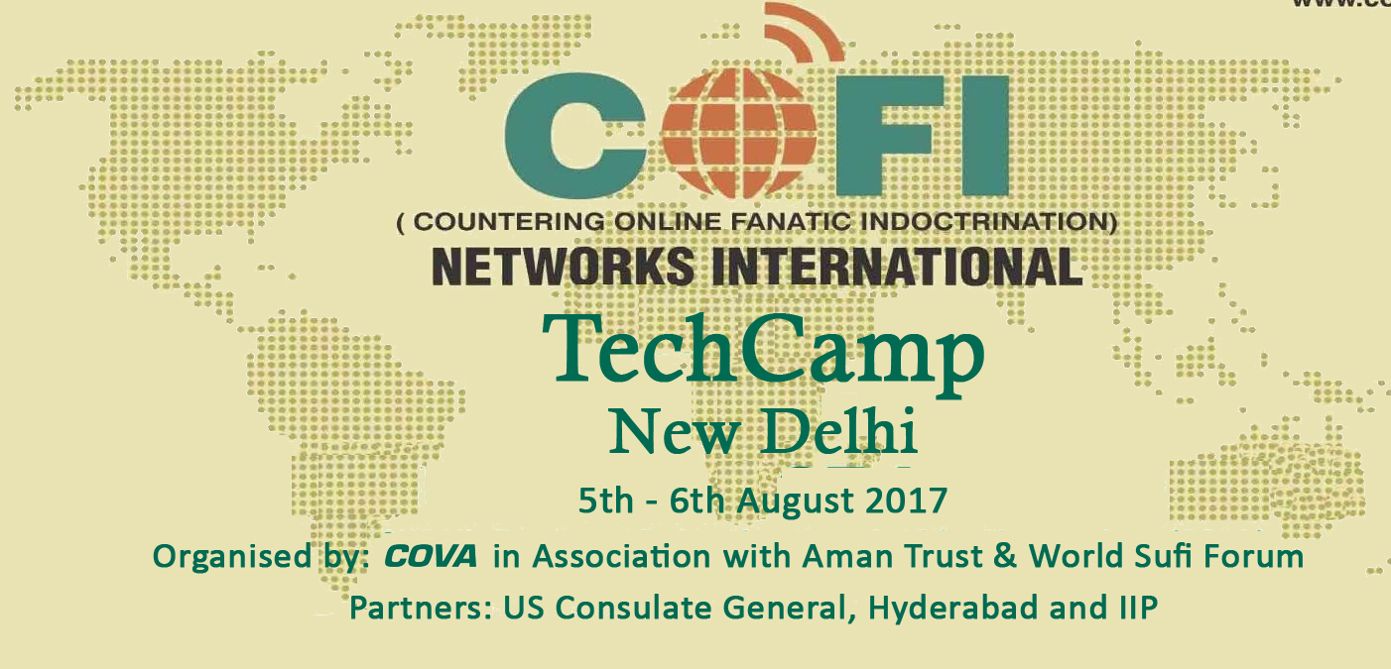

Acknowledgement

This is to acknowledge the expert contribution of
Neelakshi Malik
in Delhi TechCamp held on 5th & 6th August 2017 as a resource person that enabled participants from New Delhi to gain expertise in usage of Social Media to Counter Online Fanaticism and promote understanding and peace in cyberspace.

Mazhar Hussain Gulam Rashool Dehlvi Jamal Kidwai
Executive Director National Secretary Director
COVA World Sufi Forum AMAN Trust

