COVA
Fatwa on Water Conservation Obtained by COVA from Jamia Nizamia
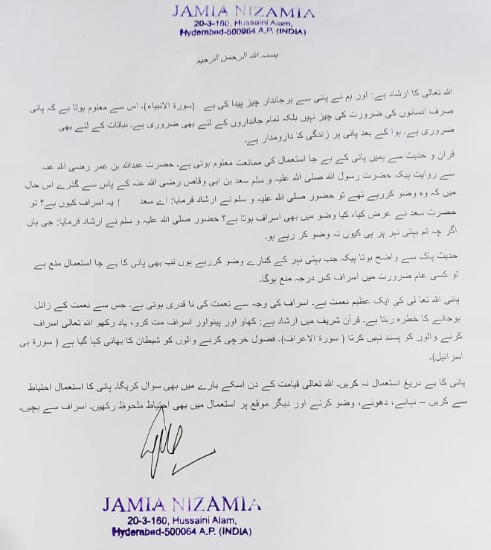
With English Translation

In the Name of Allah, Most Beneficent, Most Merciful
Allah (S.W.T) says: “We made from water every living thing” (Al-Anbya). This shows that water is not only a necessity of human beings but also essential for all beings, including flora. Life is dependent on water after air.
We get to know from the Quran and Hadith about the prohibition of misuse of water. Hz. Abdullah Bin Umar R.A. narrated that Prophet Muhammad (S.A.S) passed by Sa'd bin Abi Waqqas in a state where he was performing ablution so the Prophet (S.A.S) has reportedly said: “What this waste, O Sa’d! He replied: “Can there be waste in performing ablution?” The Prophet (S.A.S) replied: “Yes, even if you are performing ablution beside a flowing river.”
This hadith shows that even if ablution is performed beside a flowing river then also waste of water is not allowed. So imagine to what extent use of water wastefully would be forbidden for regular necessities.
Water is a great boon from Allah (S.W.T). Its wasteful use would be an inappreciation. It may result in loss of this boon. It is said in the Quran: “Eat and drink, but do not waste. Surely He does not like the wasteful.” (Al-A'raf) The wasteful are called brothers of Satan. (Bani Israel)
Therefore, do not use water excessively. Allah (S.W.T) would ask about its use in the Day of Judgment. Use water judiciously—for bathing, washing, ablution, and other needs. Do not waste it.

