Create a Support Campaign in Your Name for the Scholarships Program of COVA in Milaap Crowd Funding Platform!
It is Simple!!
Your friends, family and people who know you can contribute and help us
Achieve the goal faster to raise the required funds.
Please note: All funds raised will go to the Scholarships Program

Steps To Follow To Create A Support Campaign In Milaap

Step 1: Go to COVA Peace Networks Campaign in Milaap:
Help Students to get Government Scholarships to Continue Education
OR
Please click here for the Link: https://milaap.org/fundraisers/support-students-135
You will see the following Page
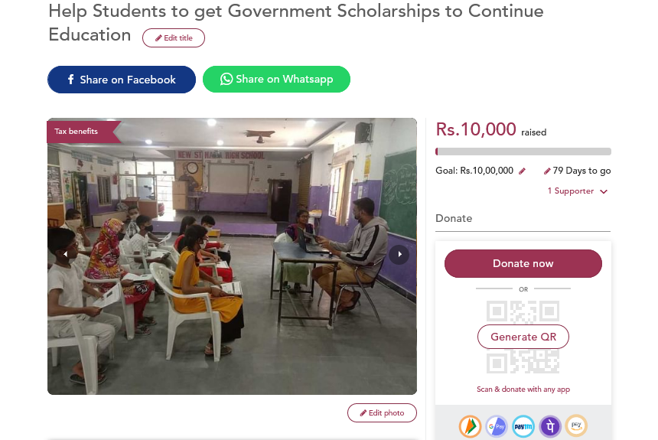
STEP 2: Once you have opened the campaign page by clicking on the Link,
Scroll down to the bottom of the Campaign Page and you will find a button - CREATE A SUPPORT FUNDRAISER.
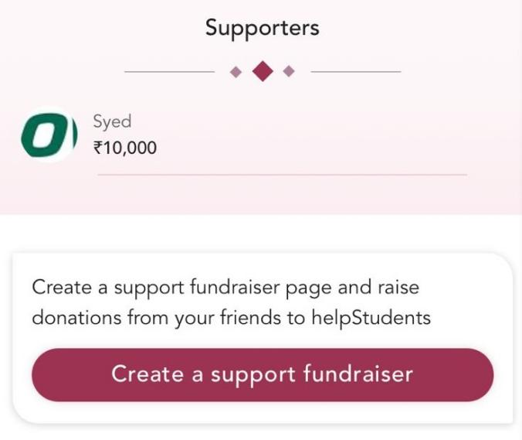

STEP 3: Please click on Create a Support fundraiser button and a pop up window/box will appear.
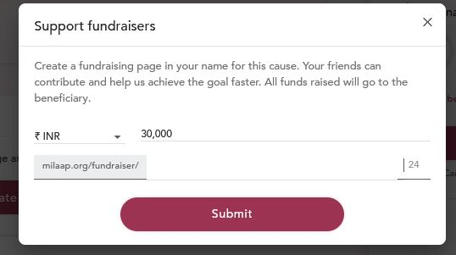
There would be two tabs
- Tab One: Amount in INR/USD can be chosen in this section. Please add the desired amount you wish to raise/collect through your support fundraiser for COVA Peace Networks Campaign.
Please note: The amount tab by default comes to 30,000 rupees as target amount to raise for the support fundraiser. The minimum amount for the fundraiser to raise is Rs.10,000. Maximum could be up to 10 lakhs. Please try to aim to raise as high an amount as possible by you for this worthy cause.

- Tab Two: This is a link generator. Please write your name in this section and the Support Fundraiser link will be generated in your name.

STEP 4: After you have added the desired amount you wish to raise along with your name, please click on SUBMIT button.
FOR EAMPLE:
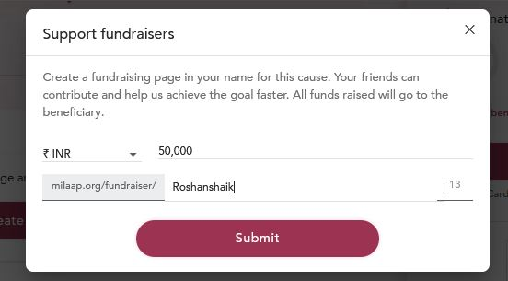
Please clink on the link to have an idea about how the above Support Campaign looks on the Milaap Crowd Funding Platform:
https://milaap.org/fundraisers/Roshanshaik

STEP 5: After you click on SUBMIT button, you will be redirected to Milaap Login page.
Please login through your credentials if you already have an account on Milaap through your mobile number or email ID that are linked to your Milaap Account.
If you DONOT have an account on Milaap and want to create an account
Please click on the Sign up button below the page and register yourself.

You can also Login through Facebook or Google (Gmail) by clicking on the buttons given on top of the page

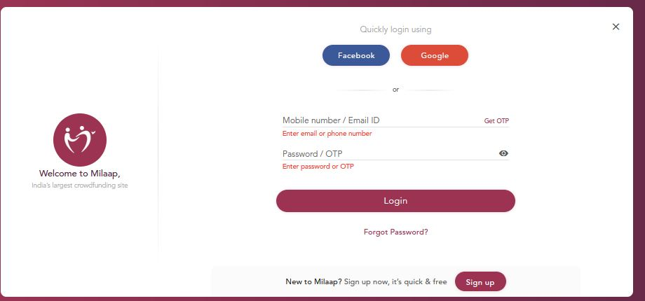
Please Note: For creating your Milaap Account- you can create any password and do not have to give the password of your email account.

STEP 6: Once you have successfully logged in a SUPPORT CAMPAIGN a FUNDRAISER will be created on your name as the campaign organizer.

STEP 7: Start sharing the Campaign with your friends, family and colleagues through Facebook and Whatsapp by clicking on the buttons that are located right below the headline of the campaign.

STEP 8: Once you have successfully created and shared your Support Campaign/Fundraiser please inform the team of COVA Peace Network and send the link of your campaign for our records.

The Team of COVA Peace Network Thanks you for your Partnership and Wishes you all the best for fundraising.

If you are facing any technical difficulties or have queries regarding the campaign.
Please contact:
ROSHAN (Communication and PR Officer- COVA Peace Network)
Email- crmo@covanetwork.org
Mobile No. +91 7330405064

